HAZARD REGISTER & RISK ASSESSMENT
Civil Works - Precast Columns and First Floor Formwork
Ref: ALT-RA-2026-5351 | Date: 21/03/2026 | Risk Level: HIGH | PROJECT COUNTRY: Netherlands
WORK DESCRIPTION
Precast columns, timber formwork and scaffold props for first floor pour. Materials staged on wet slab, manual handling of heavy beams. COSHH: formwork release oil, hexavalent chromium, timber dust, silica dust.
OVERVIEW
High-risk construction activity involving precast column installation, timber formwork assembly, and concrete pour preparation on wet surfaces. Multiple severe hazards identified including working at height, manual handling of heavy materials, structural instability risks, and chemical exposure requiring comprehensive control measures.
# | HAZARD | PERSONS AT RISK | INITIAL RISK | CONTROL MEASURES | RESIDUAL RISK | APPLICABLE STANDARD
1. | Working at Height - Formwork Assembly — Workers assembling timber formwork and scaffold props at elevation for first floor construction, risk of falls from height during installation and adjustment activities | Formwork carpenters, scaffold erectors, general construction workers | L4 x S5 = 20  CRITICAL | Collective fall protection systems installed, working platforms with guardrails and toe boards, fall arrest harnesses for edge work, exclusion zones below work area, competent supervision and method statements | L2 x S4 = 8  HIGH | EU Dir 2001/45/EC + Arbowet Article 3.5a
2. | Manual Handling - Heavy Precast Elements — Lifting and positioning of heavy precast columns and timber beams exceeding safe manual handling limits, risk of musculoskeletal injury and crush injuries | Crane operators, riggers, construction workers, supervisors | L4 x S4 = 16  CRITICAL | Mechanical lifting equipment for all heavy elements, trained lifting teams with appointed person, proper lifting accessories and slings, team lifting procedures where necessary, manual handling training | L2 x S3 = 6  MEDIUM | EU Dir 90/269/EEC + Arbowet Article 3.46
3. | Structural Collapse - Temporary Works — Risk of formwork or scaffold prop failure during construction due to inadequate design, installation or loading, potentially causing catastrophic collapse | All site personnel, formwork carpenters, concrete workers | L3 x S5 = 15  CRITICAL | Engineered temporary works design by competent person, regular inspections by temporary works coordinator, load calculations verified, proper bracing and support systems, staged construction sequence | L1 x S5 = 5  MEDIUM | EN 12812 + Arbowet Article 3.5
4. | Slips and Falls - Wet Slab Conditions — Materials staged on wet concrete slab creating slippery walking surfaces with increased risk of slips, trips and falls at ground level | All site workers, delivery personnel, supervisory staff | L4 x S3 = 12  HIGH | Non-slip footwear mandatory, designated walkways marked and maintained, water removal systems, regular housekeeping, adequate lighting, warning signage for wet areas | L2 x S2 = 4  MEDIUM | EU Dir 89/391/EEC + Arbowet Article 3.1
5. | Chemical Exposure - Formwork Release Agents — Inhalation and skin contact with formwork release oils and chemical agents during application, risk of respiratory irritation and dermatitis | Formwork carpenters, concrete finishers, maintenance workers | L3 x S3 = 9  HIGH | Local exhaust ventilation where practicable, respiratory protective equipment FFP2 minimum, chemical-resistant gloves and coveralls, eye protection, adequate welfare facilities for washing | L1 x S2 = 2  LOW | EU Dir 98/24/EC + Arbowet Article 4.2
6. | Silica Dust Exposure — Generation of respirable crystalline silica dust during cutting, grinding or drilling of concrete elements, risk of silicosis and lung disease | Concrete cutters, drillers, nearby workers, plant operators | L3 x S4 = 12  HIGH | Water suppression systems for cutting operations, local exhaust ventilation, respiratory protection FFP3 minimum, health surveillance program, air monitoring, designated work zones | L1 x S3 = 3  LOW | EU Dir 2003/10/EC + Arbowet Article 4.2
7. | Lifting Operations - Crane Activities — Overhead lifting of precast elements and materials using mobile or tower crane, risk of load drops, structural damage, and personnel injury | Crane operators, banksmen, riggers, ground workers | L3 x S4 = 12  HIGH | Certified crane operators, appointed person supervising lifts, exclusion zones enforced, pre-use inspections, lifting plan and risk assessment, proper rigging equipment with current certificates | L1 x S4 = 4  MEDIUM | EN 13000 + Arbowet Article 3.19
8. | Hexavalent Chromium Exposure — Exposure to hexavalent chromium from cement and concrete work, risk of skin sensitization, respiratory irritation and potential carcinogenic effects | Concrete workers, formwork carpenters, finishing trades | L2 x S4 = 8  HIGH | Chromium-reduced cement specification where possible, barrier creams and chemical-resistant gloves, respiratory protection during dusty operations, health surveillance, immediate washing facilities | L1 x S3 = 3  LOW | EU Dir 2003/10/EC + Arbowet Article 4.2
REQUIRED ACTIONS BEFORE WORK BEGINS
• Implement comprehensive temporary works design and inspection regime
• Establish exclusion zones below all lifting operations and elevated work
• Ensure mechanical handling for all precast elements exceeding manual limits
• Deploy water suppression systems for silica-generating activities
• Conduct pre-start briefings covering chemical hazards and PPE requirements
• Verify competency of all lifting team personnel and equipment certification

📷 SITE PHOTO OBSERVATIONS
Aerial view of active construction site showing concrete slab with extensive rebar installation, multiple material storage areas, ongoing formwork activities, and workers present across the site. Wet conditions visible on slab surface with various construction materials staged throughout work area.
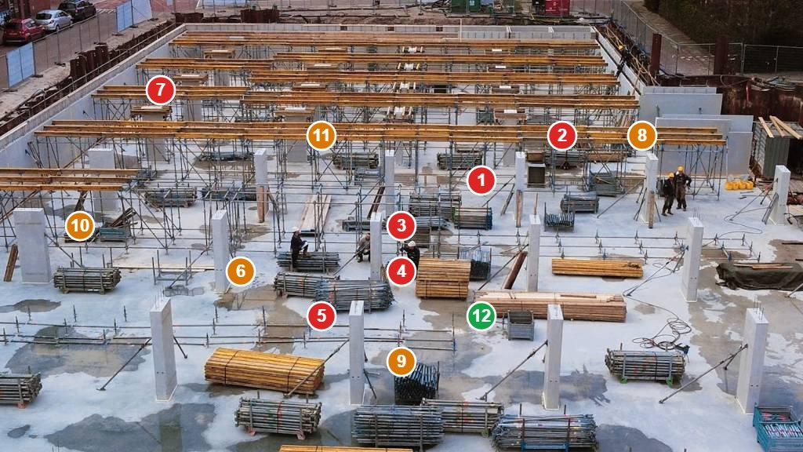
# | FINDING | RISK (L×S) | STANDARD | ACTION REQUIRED
1 | Multiple workers operating on improvised working platforms constructed from loose boards placed across scaffold tubes without proper guardrails, toe boards, or safe access - visible throughout center and right areas of slab | L5 x S5 = 25  CRITICAL | EN 12811 / Arbowet Article 3.5a | STOP WORK - Install compliant working platforms with guardrails, mid-rails, toe boards and safe access ladders
2 | Workers at significant height above slab level without any visible fall protection systems or collective fall prevention measures - particularly evident in center-right area | L4 x S5 = 20  CRITICAL | EU Dir 2001/45/EC / Arbowet Article 3.5a | Install collective fall protection systems immediately - guardrails, safety nets, or ensure all workers wear fall arrest harnesses
3 | Extensive tall vertical rebar columns throughout site creating severe impalement hazard - multiple locations across entire slab area without visible protection caps | L3 x S5 = 15  CRITICAL | EN 13670 / Arbowet Article 3.1 | Install mushroom caps or protective covers on all protruding rebar ends immediately
4 | No visible exclusion zones established below elevated work activities where workers are operating at height on platforms | L4 x S5 = 20  CRITICAL | EU Dir 89/391/EEC / Arbowet Article 3.1 | Establish and mark exclusion zones below all elevated work areas to prevent falling object injuries
5 | Short rebar starter bars protruding from slab surface creating trip and impalement hazards for personnel walking across the work area | L4 x S4 = 16  CRITICAL | EN 13670 / Arbowet Article 3.1 | Install protective caps on short rebar stubs and establish marked walkways
6 | Large quantities of construction materials (timber, steel) stored directly on wet slab surface creating trip hazards and obstructing emergency access routes | L4 x S3 = 12  HIGH | EU Dir 89/391/EEC / Arbowet Article 3.1 | Relocate materials to designated storage areas, maintain clear walkways and emergency routes
7 | Building perimeter lacks visible edge protection barriers with potential for falls from slab edges to lower levels | L3 x S5 = 15  CRITICAL | EN 13374 / Arbowet Article 3.5a | Install perimeter edge protection barriers meeting Class A requirements around entire slab edge
8 | Workers visible without consistent hard hat usage across the site - several personnel in various locations | L3 x S4 = 12  HIGH | EN 397 / Arbowet Article 3.2 | Enforce mandatory hard hat policy for all personnel on site, conduct toolbox talk on PPE requirements
9 | Wet slab conditions visible throughout site creating slip hazards combined with scattered materials on walking surfaces | L4 x S3 = 12  HIGH | EU Dir 89/391/EEC / Arbowet Article 3.1 | Improve drainage, provide non-slip walkways, ensure all personnel wear appropriate slip-resistant footwear
10 | Inadequate segregation between pedestrian workers and potential vehicle/plant access areas around site perimeter | L3 x S4 = 12  HIGH | EU Dir 92/57/EEC / Arbowet Article 3.1 | Install physical barriers to separate pedestrian and vehicle zones, establish designated access routes
11 | No visible safety signage or warning systems for multiple hazardous areas including work at height zones and material storage areas | L3 x S3 = 9  HIGH | EU Dir 89/391/EEC / Arbowet Article 3.1 | Install appropriate warning signage for all hazardous areas and work zones
12 | Formwork timber and construction debris scattered across work surfaces creating additional housekeeping hazards | L3 x S2 = 6  MEDIUM | EU Dir 89/391/EEC / Arbowet Article 3.1 | Implement regular housekeeping schedule, provide adequate waste containers, maintain tidy work areas

☣ COSHH / CHEMICAL AGENTS ASSESSMENT (DIRECTIVE 98/24/EC)
SUBSTANCE | HEALTH RISK | EXPOSURE LIMIT | PPE REQUIRED | CONTROLS | STORAGE | SDS
Formwork Release Oil | Skin and respiratory irritation, dermatitis from prolonged contact, inhalation of vapors in confined spaces | Skin contact during application, inhalation of vapors, eye splash risk | Chemical-resistant gloves EN 374, safety glasses EN 166, respiratory protection FFP2 when ventilation inadequate | Local exhaust ventilation where practicable, avoid skin contact, use brush or spray application to minimize exposure | Store in original containers in cool, dry area away from ignition sources, ensure adequate ventilation | Safety Data Sheet available on site referencing CLP Regulation classification and first aid procedures
Hexavalent Chromium (from cement) | Skin sensitization, allergic contact dermatitis, respiratory irritation, classified carcinogen Category 1A | Skin contact with wet cement, inhalation of cement dust during mixing and finishing operations | Chemical-resistant gloves EN 374, respiratory protection FFP3 for dusty operations, protective clothing EN 14325 | Use chromium-reduced cement where possible, minimize skin contact, provide immediate washing facilities, health surveillance | Store cement in dry conditions, prevent dust generation, use mechanical handling to minimize manual contact | Safety Data Sheet available detailing carcinogenic classification and occupational exposure limits under REACH
Wood Dust (from timber formwork) | Respiratory irritation, allergic reactions, hardwood dust classified as carcinogen, fire and explosion risk | Inhalation during cutting, sanding, and machining operations, skin and eye contact with dust particles | Respiratory protection FFP3 EN 149, safety glasses EN 166, dust masks insufficient for hardwood species | Local exhaust ventilation on cutting equipment, water suppression where possible, regular housekeeping to prevent accumulation | Store timber in designated areas away from ignition sources, maintain good ventilation, prevent dust accumulation | Material safety information available including species identification and dust control measures
Respirable Crystalline Silica | Silicosis, lung cancer, kidney disease, chronic obstructive pulmonary disease, classified carcinogen Category 1A | Inhalation during cutting, drilling, grinding of concrete and masonry materials, highest risk during dry operations | Respiratory protection FFP3 EN 149 minimum, powered air purifying respirator for extended exposure, protective clothing | Water suppression mandatory for cutting operations, local exhaust ventilation, air monitoring program, health surveillance | Minimize handling of silica-containing materials in dry state, use wet methods, prevent dust generation and accumulation | Health hazard information available including occupational exposure limits 0.1 mg/m³ respirable fraction (8-hour TWA)
Diesel Engine Exhaust | Respiratory irritation, suspected carcinogen, cardiovascular effects from particulate matter exposure | Inhalation of exhaust fumes from construction plant and vehicles in work areas | Respiratory protection may be required in confined areas or during extended exposure periods | Maintain equipment in good condition, ensure adequate ventilation, minimize idling time, use newer emission-controlled equipment | Fuel storage in designated areas with appropriate containment and fire protection measures | Safety information available for diesel fuel and exhaust emission hazard data
Concrete Additives and Admixtures | Skin and eye irritation, allergic reactions, some additives may contain harmful chemical components | Skin contact during mixing and application, potential splash to eyes, inhalation of dust or vapors | Chemical-resistant gloves EN 374, safety glasses EN 166, protective clothing for extensive concrete work | Follow manufacturer instructions, avoid skin contact, provide eyewash facilities, ensure good ventilation | Store according to manufacturer requirements, prevent contamination, maintain temperature control where specified | Individual Safety Data Sheets required for all concrete admixtures and additives used on site
This document was produced by an AI system (Alertitude.eu – Let’s assess your risk, Alertitude d.o.o., Slovenia). It is provided for internal planning purposes only and does not constitute professional safety advice, a statutory risk assessment, or legal compliance documentation. Content must be reviewed and validated by a competent person before use. AI-generated content may contain errors or omissions. Alertitude d.o.o. accepts no liability for decisions made on the basis of this output. | EU AI Act Art. 50 — Limited Risk AI System | UK AI Principles Framework

