HAZARD REGISTER & RISK ASSESSMENT
Structural Works - Crane Lifting Prefabricated Elements with MEWP Bolt-Up Operations
Ref: ALT-RA-2026-3676 | Date: 21/03/2026 | Risk Level: HIGH | PROJECT COUNTRY: Spain
WORK DESCRIPTION
Crane lifting prefabricated columns and beams, bolt-up at 6–8m from diesel MEWPs. Multiple diesel plant near ground workers. COSHH: diesel exhaust particulates, grout dust, anti-seize compound, hydraulic oil mist.
OVERVIEW
High-risk precast concrete erection involving mobile crane operations, working at height from MEWPs at 6-8m elevation, and multiple diesel plant operations with ground workers present. Key hazards include falling objects from height, plant collision/crushing, diesel exhaust exposure, and coordination failures between crane and MEWP operations. Multiple chemical agent exposures require comprehensive COSHH controls.
# | HAZARD | PERSONS AT RISK | INITIAL RISK | CONTROL MEASURES | RESIDUAL RISK | APPLICABLE STANDARD
1. | Falling Objects from Crane Operations — Risk of dropped loads, tools, or structural elements falling from crane hook or MEWP basket during lifting and positioning operations at 6-8m height | All ground workers, plant operators, visitors within crane radius | L4 x S5 = 20  CRITICAL | Exclusion zones marked and enforced around crane operations. Tool lanyards mandatory in MEWP baskets. Lifting accessories inspected daily. Banksman directing all lifts. Hard hats with chin straps mandatory. No personnel under suspended loads. | L2 x S5 = 10  HIGH | EU Dir 2009/104/EC + LPRL 31/1995
2. | Working at Height from MEWPs — Workers in MEWP baskets at 6-8m elevation for bolt-up operations with risks of falls, crushing against structures, or basket overturn | MEWP operators and passengers | L3 x S5 = 15  CRITICAL | MEWP operators trained and certified. Pre-use inspections completed. Fall arrest harnesses worn and attached to basket anchor points. Ground conditions assessed for stability. Safe working loads not exceeded. Emergency descent procedures established. | L2 x S4 = 8  HIGH | EU Dir 2001/45/EC + LPRL 31/1995
3. | Plant Collision and Crushing — Multiple diesel plant operating in confined area with ground workers present creating collision risks between crane, MEWPs, and personnel | All site personnel, plant operators | L4 x S4 = 16  CRITICAL | Designated plant routes marked. Banksmen assigned for all plant movements. Two-way radio communication between all operators. Hi-vis PPE mandatory. Exclusion zones around operating plant. Speed limits enforced on site. | L2 x S4 = 8  HIGH | EU Dir 2009/104/EC + LPRL 31/1995
4. | Diesel Exhaust Exposure — Multiple diesel engines operating (crane, MEWPs, other plant) generating particulate matter and NOx emissions harmful to respiratory system | All site workers, particularly those near plant | L5 x S3 = 15  CRITICAL | Plant positioned to minimize exhaust exposure to workers. Regular maintenance ensuring optimal combustion. RPE (FFP2 minimum) provided for prolonged exposure. Health surveillance for regular diesel-exposed workers. Work rotation to minimize individual exposure. | L3 x S2 = 6  MEDIUM | EU Dir 98/24/EC + LPRL 31/1995
5. | Structural Instability During Erection — Partially erected precast structure may be unstable during construction with risk of progressive collapse if temporary bracing inadequate | All personnel on site | L2 x S5 = 10  HIGH | Temporary stability calculations verified by structural engineer. Progressive bracing installed per approved sequence. Wind loading monitored - work stopped in high winds. Daily stability inspections by competent person. Emergency evacuation procedures established. | L1 x S5 = 5  MEDIUM | EU Dir 92/57/EEC + LPRL 31/1995
6. | Hydraulic System Failure — Hydraulic failure in crane or MEWP causing uncontrolled movement, load drop, or boom collapse with potential for multiple fatalities | Plant operators, ground workers within operating radius | L2 x S5 = 10  HIGH | Daily pre-use hydraulic system inspections. Pressure testing per manufacturer schedule. Load moment indicators functional and calibrated. Automatic safe load indicators operational. Emergency lowering systems tested. Competent operators only. | L1 x S5 = 5  MEDIUM | EU Dir 2009/104/EC + LPRL 31/1995
7. | Manual Handling Injuries — Lifting, positioning, and handling of bolts, tools, and equipment during bolt-up operations causing musculoskeletal injuries | Workers performing bolt-up operations | L4 x S2 = 8  HIGH | Manual handling training provided. Team lifting for heavy items. Mechanical aids used where practicable. Job rotation to prevent repetitive strain. Pre-shift warm-up exercises. Ergonomic tool selection. | L2 x S2 = 4  MEDIUM | EU Dir 90/269/EEC + LPRL 31/1995
8. | Chemical Agent Exposure — Exposure to grout dust, anti-seize compounds, and hydraulic oil mist causing respiratory irritation, dermatitis, and potential systemic effects | Workers handling chemicals, those in vicinity of chemical use | L4 x S3 = 12  HIGH | Safety data sheets available and reviewed. Appropriate PPE for each substance. Local exhaust ventilation where practicable. Eye wash stations provided. Chemical storage in designated areas. Spill kits readily available. Health surveillance program implemented. | L2 x S2 = 4  MEDIUM | EU Dir 98/24/EC + LPRL 31/1995
REQUIRED ACTIONS BEFORE WORK BEGINS
• Establish and maintain exclusion zones around all crane operations
• Implement banksman system for all lifting operations and plant movements
• Verify MEWP operator competency and conduct pre-use inspections
• Conduct daily toolbox talks covering lifting sequence and emergency procedures
• Monitor weather conditions and suspend operations in adverse conditions
• Implement health surveillance program for chemical and diesel exhaust exposure

📷 SITE PHOTO OBSERVATIONS
Large-scale precast concrete construction site showing white structural frame being erected with mobile crane. Multiple plant visible including crane, MEWPs, and support vehicles. Ground-level workers present near active lifting operations. Site appears to be early stages of industrial building construction with organized material storage areas.
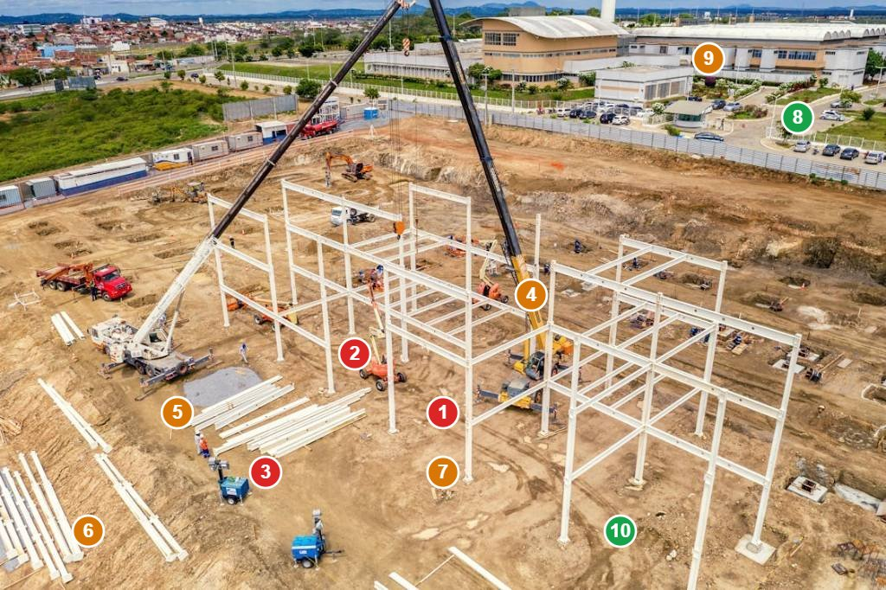
# | FINDING | RISK (L×S) | STANDARD | ACTION REQUIRED
1 | Ground workers visible within crane operating radius during active lifting operations with suspended load overhead - immediate crushing/falling object hazard | L5 x S5 = 25  CRITICAL | EU Dir 2009/104/EC + LPRL 31/1995 | Establish immediate exclusion zone - remove all personnel from crane radius until lift complete
2 | No visible exclusion zone barriers or markings around crane operations despite multiple personnel present in hazardous area | L4 x S5 = 20  CRITICAL | EU Dir 92/57/EEC + LPRL 31/1995 | Install physical barriers and warning signage to define exclusion zones around all plant operations
3 | Multiple diesel plant operating simultaneously (crane, MEWPs, vehicles) without visible segregation creating collision hazards | L4 x S4 = 16  CRITICAL | EU Dir 2009/104/EC + LPRL 31/1995 | Implement traffic management plan with designated routes and banksmen for plant movements
4 | MEWP positioned close to crane operations without visible coordination protocols - risk of collision between plant | L3 x S4 = 12  HIGH | EU Dir 2009/104/EC + LPRL 31/1995 | Establish radio communication between all plant operators and implement coordination protocol
5 | Precast concrete elements stored at ground level without adequate segregation from pedestrian areas | L3 x S3 = 9  HIGH | EN 13374 + LPRL 31/1995 | Install barriers around stored materials and designate pedestrian walkways
6 | No visible emergency assembly point or evacuation signage for site personnel in event of plant emergency | L2 x S4 = 8  HIGH | EU Dir 89/391/EEC + LPRL 31/1995 | Install emergency assembly point signage and conduct evacuation drill
7 | Ground conditions appear uneven with exposed soil/aggregate creating slip/trip hazards for workers | L4 x S2 = 8  HIGH | EU Dir 92/57/EEC + LPRL 31/1995 | Grade and compact walking surfaces, provide temporary roadway where needed
8 | No visible first aid facilities or emergency contact information posted at site boundaries | L2 x S3 = 6  MEDIUM | EU Dir 89/391/EEC + LPRL 31/1995 | Install first aid station and emergency contact signage at main site entrance
9 | Site perimeter fencing appears incomplete allowing potential unauthorized access to active construction zone | L3 x S3 = 9  HIGH | EU Dir 92/57/EEC + LPRL 31/1995 | Complete perimeter fencing and install 'Authorized Personnel Only' signage
10 | No visible environmental controls for dust suppression despite disturbed ground conditions | L3 x S2 = 6  MEDIUM | EU Dir 98/24/EC + LPRL 31/1995 | Implement dust suppression measures including water spraying for haul roads

☣ COSHH / CHEMICAL AGENTS ASSESSMENT (DIRECTIVE 98/24/EC)
SUBSTANCE | HEALTH RISK | EXPOSURE LIMIT | PPE REQUIRED | CONTROLS | STORAGE | SDS
Diesel Exhaust Particulates | Respiratory irritation, potential carcinogen (IARC Group 1). Long-term exposure linked to lung cancer and cardiovascular effects | OEL: 50 μg/m³ respirable fraction (8-hour TWA) | FFP2 respiratory protection minimum, FFP3 for prolonged exposure | Position plant upwind of workers, regular maintenance, work rotation, enclosed cabs where possible | Fuel stored in designated bunded area away from ignition sources | Safety data sheet available for diesel fuel - review health hazards section
Cement/Grout Dust | Respiratory irritation, silicosis risk, skin/eye irritation, allergic dermatitis from chromates | WEL: 4 mg/m³ respirable dust (8-hour TWA) | FFP2 respirator, chemical-resistant gloves, eye protection, coveralls | Wet mixing where possible, local exhaust ventilation, minimize dust generation | Store in dry conditions, sealed containers, separate from incompatible materials | Review cement safety data sheet for chromate content and exposure controls
Anti-Seize Compound | Skin irritation, eye damage, respiratory irritation. May contain heavy metals (copper, nickel) | No specific OEL - minimize skin contact and inhalation | Chemical-resistant gloves (nitrile), safety glasses, respiratory protection if spray application | Use brush application rather than spraying, adequate ventilation, immediate spill cleanup | Store in original containers, cool dry place, away from oxidizing agents | Consult manufacturer SDS for specific formulation hazards and first aid measures
Hydraulic Oil Mist | Respiratory irritation, skin irritation, slip hazard from spills. May contain additives with health effects | OEL: 1 mg/m³ oil mist (8-hour TWA) | Nitrile gloves when handling, eye protection, respiratory protection if high mist levels | Regular system inspection for leaks, immediate cleanup of spills, adequate ventilation | Store hydraulic fluid in designated area with spill containment | Review hydraulic oil safety data sheet for specific additive hazards and disposal requirements
This document was produced by an AI system (Alertitude.eu – Let’s assess your risk, Alertitude d.o.o., Slovenia). It is provided for internal planning purposes only and does not constitute professional safety advice, a statutory risk assessment, or legal compliance documentation. Content must be reviewed and validated by a competent person before use. AI-generated content may contain errors or omissions. Alertitude d.o.o. accepts no liability for decisions made on the basis of this output. | EU AI Act Art. 50 — Limited Risk AI System | UK AI Principles Framework

