HAZARD REGISTER & RISK ASSESSMENT
Fire Protection Works - Valve Replacement and Diesel Pump Inspection
Ref: ALT-RA-2026-7846 | Date: 21/03/2026 | Risk Level: HIGH | PROJECT COUNTRY: Germany
WORK DESCRIPTION
Valve replacement on 150mm wet riser mains, diesel pump inspection, solvent cleaning of corroded flanges. Confined plant room, occupied building. COSHH: solvents, sealants, diesel, corrosion products.
OVERVIEW
High-risk fire protection maintenance work in confined plant room of occupied building involving valve replacement on 150mm wet riser mains, diesel pump inspection, and chemical cleaning operations. Critical hazards include confined space working, chemical exposure, manual handling of heavy components, and potential service disruption to building occupants. Enhanced controls required for occupied environment coordination and COSHH compliance.
# | HAZARD | PERSONS AT RISK | INITIAL RISK | CONTROL MEASURES | RESIDUAL RISK | APPLICABLE STANDARD
1. | Confined Space Working - Plant Room — Work in confined plant room with limited ventilation, restricted access/egress, potential for atmospheric contamination from diesel fumes and solvent vapors | Maintenance technicians, emergency responders | L4 x S5 = 20  CRITICAL | Atmospheric monitoring before entry and continuously during work. Forced ventilation system. Emergency escape breathing apparatus available. Permit to work system. Standby person outside space. Emergency rescue plan established. Regular air quality checks for diesel exhaust and solvent vapors. | L2 x S4 = 8  HIGH | EU Dir 89/391/EEC + ArbSchG § 3 / DGUV Regel 113-004
2. | Chemical Exposure - Solvents and Cleaning Agents — Exposure to organic solvents during flange cleaning operations causing respiratory irritation, skin contact dermatitis, and potential systemic toxicity | Maintenance technicians | L4 x S4 = 16  CRITICAL | Use low-toxicity cleaning solvents where possible. Local exhaust ventilation at point of application. Respiratory protective equipment FFP3 or supplied air if required. Chemical-resistant gloves and coveralls. Eye protection. Minimize skin contact. Emergency eyewash station accessible. SDS review and training completed. | L2 x S3 = 6  MEDIUM | EU Dir 98/24/EC + ChemG / DGUV Regel 109-001
3. | Manual Handling - Heavy Valves and Components — Risk of musculoskeletal injury from lifting, positioning and installing 150mm valve assemblies and pump components in restricted plant room space | Maintenance technicians | L4 x S3 = 12  HIGH | Pre-work risk assessment of lifting operations. Use mechanical lifting aids, chain blocks, or portable hoists where space permits. Two-person lift for components over 23kg. Proper lifting techniques training. Clear access routes. Pre-position materials to minimize handling distance. Consider component pre-assembly outside confined space. | L2 x S2 = 4  MEDIUM | EU Dir 90/269/EEC + ArbSchG § 3 / DGUV Regel 100-001
4. | Fire System Service Disruption — Temporary loss of fire protection to occupied building areas during valve replacement creating life safety risk for occupants | Building occupants, visitors, staff | L5 x S4 = 20  CRITICAL | Coordinate with building management and fire safety officer. Implement temporary fire watch patrols during system isolation. Enhanced fire detection monitoring in affected zones. Restrict hot work activities building-wide during outage. Emergency services notification of temporary impairment. Minimize isolation time through pre-fabrication. Staged commissioning to restore protection progressively. | L3 x S3 = 9  HIGH | EU Dir 89/391/EEC + MBO § 14 / DIN 14095
5. | Diesel Fuel Exposure and Fire Risk — Risk of fire, explosion, and toxic exposure from diesel fuel during pump inspection, maintenance, and potential spillages in confined plant room | Maintenance technicians, building occupants | L3 x S5 = 15  CRITICAL | Hot work permit system - no ignition sources during fuel-related work. Spill containment materials immediately available. Portable gas detection for hydrocarbon vapors. Ensure pump isolation and fuel system de-energization. Absorbent materials and waste disposal containers. Emergency spill response procedure. Fire extinguisher suitable for Class B fires positioned nearby. | L2 x S4 = 8  HIGH | EU Dir 1999/92/EC + BetrSichV § 6 / DGUV Regel 113-001
6. | Pressurized System Isolation Failure — Risk of high-pressure water release during valve replacement if isolation is inadequate, causing injury from water jet or flooding | Maintenance technicians | L3 x S4 = 12  HIGH | Double isolation with locked-off valves upstream and downstream. Pressure testing of isolation before breaking containment. Drain-down procedures with low-point venting. Pressure gauge monitoring at work location. Controlled depressurization. Personal protective equipment including face shields. Emergency isolation valve locations identified and accessible. | L1 x S4 = 4  MEDIUM | EU Dir 2014/68/EU + BetrSichV § 15 / DGUV Regel 100-500
7. | Occupant Safety and Evacuation Risk — Potential need for emergency evacuation due to chemical spills, fire system disruption, or diesel fuel incident affecting occupied building areas | Building occupants, visitors, maintenance staff | L2 x S5 = 10  HIGH | Emergency response plan coordinated with building management. Evacuation routes kept clear during work. Emergency communication system tested. Building fire wardens briefed on work activities. Enhanced monitoring of fire detection systems. Emergency services contact information readily available. Clear evacuation signals and procedures established. | L1 x S4 = 4  MEDIUM | EU Dir 89/391/EEC + ArbStättV § 4 / ASR A2.3
8. | Corrosion Product Exposure — Inhalation and skin contact with iron oxides, scale, and potentially hazardous corrosion products during flange cleaning and system disassembly | Maintenance technicians | L4 x S3 = 12  HIGH | Respiratory protection during dust-generating activities. Wet cutting/grinding methods to suppress dust. Disposable coveralls and gloves. Eye protection mandatory. Proper waste disposal for contaminated materials. Hand washing facilities available. Pre-work health surveillance if asbestos-containing materials suspected in older systems. | L2 x S2 = 4  MEDIUM | EU Dir 2009/148/EC + GefStoffV § 7 / DGUV Regel 109-002
REQUIRED ACTIONS BEFORE WORK BEGINS
• Obtain confined space entry permit and establish atmospheric monitoring
• Implement fire watch procedures during system isolation
• Complete chemical risk assessment and provide appropriate respiratory protection
• Coordinate with building management for occupant safety measures
• Establish emergency spill response procedures for diesel and solvents
• Pre-position mechanical lifting aids for valve handling operations
• Test emergency communication systems before work commencement

📷 SITE PHOTO OBSERVATIONS
Plant room showing extensive red-painted fire protection pipework including large bore mains and valve assemblies. Single technician in hi-vis working on pipe flange connection. Confined space with limited headroom, multiple pipe runs at various elevations, concrete floor surfaces. Complex pipe routing with multiple bends, branches and valve positions throughout the space.
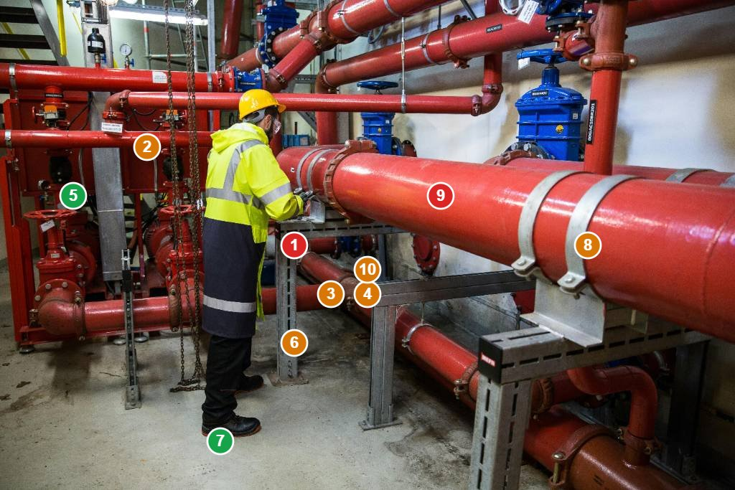
# | FINDING | RISK (L×S) | STANDARD | ACTION REQUIRED
1 | Confined space working - technician operating in plant room with limited ventilation, restricted egress routes, and multiple overhead pipe runs reducing available space | L4 x S5 = 20  CRITICAL | EU Dir 89/391/EEC + DGUV Regel 113-004 | Establish atmospheric monitoring, forced ventilation, and standby person procedure before continuing work
2 | Head strike hazard - multiple large diameter pipes at head height throughout workspace with insufficient clearance for safe movement | L4 x S3 = 12  HIGH | EN 14122-3 + ArbStättV § 3.3 | Install temporary padding on low-hanging pipes and improve task lighting to enhance hazard visibility
3 | Manual handling risk - technician working on heavy valve/flange assembly without visible mechanical aids in restricted space | L4 x S3 = 12  HIGH | EU Dir 90/269/EEC + DGUV Regel 100-001 | Provide portable lifting equipment or chain block system for valve handling operations
4 | Pressurized system exposure - worker in direct contact with large bore fire main without visible pressure isolation confirmation | L3 x S4 = 12  HIGH | EU Dir 2014/68/EU + BetrSichV § 15 | Verify and document complete system isolation with locked-off valves before proceeding with flange work
5 | Inadequate work lighting - insufficient illumination in plant room corners and under pipe runs creating trip hazards and reducing hazard visibility | L3 x S2 = 6  MEDIUM | EN 12464-1 + ArbStättV § 3.4 | Install additional portable LED work lights to achieve minimum 200 lux illumination throughout workspace
6 | Chemical exposure potential - no visible local exhaust ventilation for solvent cleaning operations in confined space | L3 x S4 = 12  HIGH | EU Dir 98/24/EC + DGUV Regel 109-001 | Install portable extraction fan and ensure respiratory protection available before chemical cleaning commences
7 | Floor surface hazards - concrete floor showing staining and potential slip risks from previous maintenance activities | L2 x S2 = 4  MEDIUM | EN ISO 13287 + ASR A1.5/1,2 | Clean floor surfaces and apply anti-slip treatment, provide absorbent materials for any new spills
8 | Emergency egress restriction - single visible exit route potentially blocked by equipment and pipe runs limiting emergency evacuation | L2 x S4 = 8  HIGH | EU Dir 89/391/EEC + ASR A2.3 | Ensure clear egress route maintained, position emergency escape breathing apparatus, establish standby person
9 | Fire protection impairment - work on active fire protection system creating temporary loss of building protection | L5 x S4 = 20  CRITICAL | DIN 14095 + MBO § 14 | Implement fire watch procedures and coordinate with building management for enhanced fire safety measures
10 | Corrosion product exposure - visible corrosion on pipe flanges and fittings creating dust hazard during cleaning operations | L3 x S3 = 9  HIGH | EU Dir 98/24/EC + GefStoffV § 7 | Provide respiratory protection and implement wet cleaning methods to control dust generation

☣ COSHH / CHEMICAL AGENTS ASSESSMENT (DIRECTIVE 98/24/EC)
SUBSTANCE | HEALTH RISK | EXPOSURE LIMIT | PPE REQUIRED | CONTROLS | STORAGE | SDS
Organic Cleaning Solvents (Trichloroethylene/Degreasing Agents) | Respiratory irritation, central nervous system depression, skin defatting, suspected carcinogen | OEL 10 ppm (8-hour TWA) - EU Dir 2009/161/EU | Respiratory protection FFP3 or supplied air, chemical-resistant gloves EN 374, face shield, coveralls | Local exhaust ventilation, minimize quantities used, substitute with less hazardous alternatives where possible | Flammable store, away from ignition sources, secondary containment, appropriate labeling | Review SDS before use, emergency contact information readily available
Diesel Fuel | Fire and explosion hazard, respiratory irritation, skin contact dermatitis, hydrocarbon vapor inhalation | OEL 100 mg/m³ (8-hour TWA) for hydrocarbon vapors | Anti-static footwear, chemical-resistant gloves, respiratory protection if required | Eliminate ignition sources, spill containment, vapor monitoring, adequate ventilation | Approved fuel storage containers, bunded area, fire separation, no smoking signs | Diesel fuel SDS available, emergency spill response procedures established
Pipe Joint Sealants and Compounds | Skin and eye irritation, respiratory sensitization, potential solvent content exposure | Follow manufacturer's exposure guidelines, typically 1-5 ppm for solvent components | Nitrile gloves, safety glasses, respiratory protection if volatile solvents present | Use in well-ventilated areas, avoid skin contact, minimize aerosol generation | Cool, dry conditions, away from heat sources, original containers with labels | Manufacturer SDS review, note any isocyanate or epoxy content requiring special precautions
Iron Oxide Corrosion Products | Respiratory irritation, eye irritation, potential for lung inflammation if heavily inhaled | General dust limit 10 mg/m³ (inhalable fraction) | Dust mask FFP2 minimum, safety glasses, disposable gloves, coveralls | Wet cutting methods, dust suppression, local exhaust where possible, minimize dust generation | Dispose as contaminated waste, double-bag dusty materials | Consider potential for asbestos in older pipe lagging, arrange testing if suspected
Threading and Cutting Oils | Skin contact dermatitis, eye irritation, mist inhalation causing respiratory irritation | OEL 5 mg/m³ (8-hour TWA) for oil mist | Oil-resistant gloves, safety glasses, respiratory protection if mist generated | Minimize mist generation, contain spillages, adequate ventilation during cutting operations | Prevent contamination, fire-resistant storage if flash point below 60°C | Check for additives and biocides that may require additional precautions
This document was produced by an AI system (Alertitude.eu – Let’s assess your risk, Alertitude d.o.o., Slovenia). It is provided for internal planning purposes only and does not constitute professional safety advice, a statutory risk assessment, or legal compliance documentation. Content must be reviewed and validated by a competent person before use. AI-generated content may contain errors or omissions. Alertitude d.o.o. accepts no liability for decisions made on the basis of this output. | EU AI Act Art. 50 — Limited Risk AI System | UK AI Principles Framework

